**AIRLINE MANAGEMENT SYSTEM   
ID:LTVIP2024TMID11564  
TEAM LEADER: K.ABHILASH  
  
TEAM MEMBER:V.MURUGA RAJU**

# Creating A Custom Tab(Flight)

To create a Tab(Flight )

1. Go to setup page --> type Tabs in Quick Find bar --> click on tabs --> New (under custom object tab)

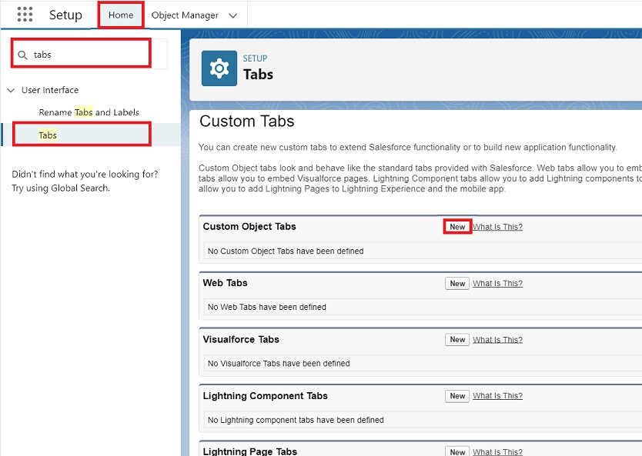

# Creating A Custom Tab(Booking)

To create a Tab (Booking )

1. Go to setup page --> type Tabs in Quick Find bar --> click on tabs --> New (under custom object tab)
2. Select Object(Booking) Select the tab style --> Next (Add to profiles page) keep it as default --> Next (Add to Custom App) keep it as default --> Save.

**Activity 3**

Now create tabs for Crew and Passengers objects.

# Create A Lightning App

To create a lightning app page:

1. Go to setup page --> search “app manager” in quick find -->select “app manager” -->click on New lightning App.

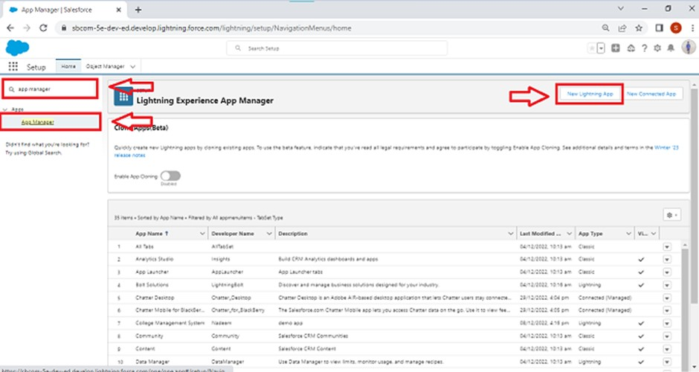

1. Fill the app name in app details and branding as follow

App Name : AirLine Management System

Developer Name : this will auto populated

Description : Give a meaningful description

Image : optional (if you want to give any image you can otherwise not mandatory) Primary color hex value : keep this default

1. Then click Next --> (App option page) keep it as default --> Next --> (Utility Items) keep it as default --> Next.

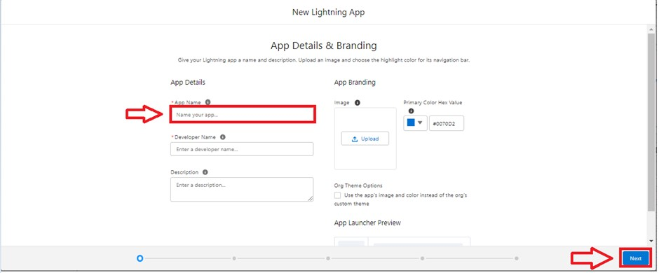

1. To Add Navigation Items:

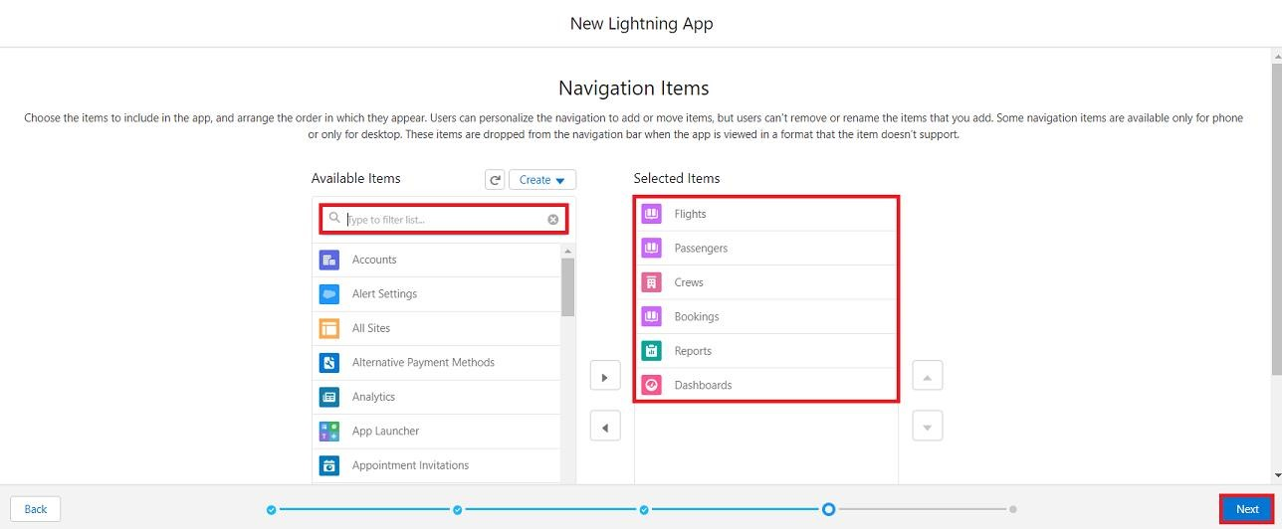

Search the items in the search bar(Flight, Passengers, Booking, Crew, Reports, Dashboard) from the search bar and move it using the arrow button --> Next.

Note: select the custom object which we have created in the previous activity.

1. To Add User Profiles:

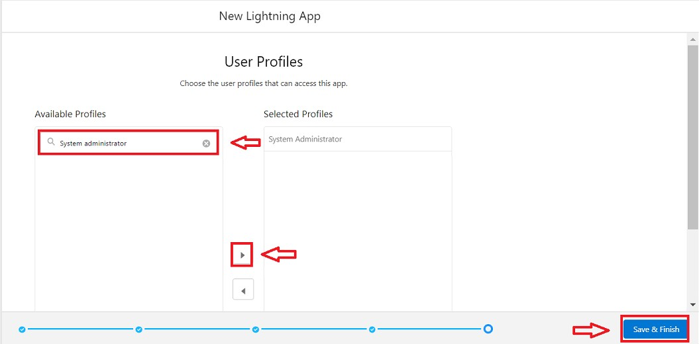

Search profiles (System administrator) in the search bar --> click on the arrow button -> save & finish.